Arts and disability interfaces

new technology, disabled artists and audiences
part 4 of 4: images

Document meta data
Name: distech-images.doc
Title: Arts and disability interfaces: part 4 of 4: images
Relation: Disability Interfaces scoping study, document 4 of 4
Identifier: (if/when available online, URL required here)
Publisher: the Arts Council of England
Date: 06/11/02
Version: 1.0
Status: final
Type: scoping study
Language: en
Format: Microsoft Word
Coverage: Europe, UK, USA, Australia
Creator: David Everitt, email: deveritt@innotts.co.uk, telephone: 01664 568316, address: 30 Woodland Avenue, Melton Mowbray, Leicestershire LE13 1DZ
Contributor: Greg Turner, role: advisor
Contributor: Mike Quantrill, role: advisor
Contributor: Juliet Robson, role: advisor
Subject: images for a factual survey with descriptions of new technologies of known or potential relevance to disabled artists and audiences
Keywords: technology, disability, disabled, access, equality, assistive, impairment, art, audiences, computing, computers, software, pervasive, digital, creative
Description: images to accompany a document on
Rights: The creator of this document grants to the Arts Council of England or its agents the right to archive and to make the document or its contents in whole or in part available through the Arts Council, in all forms of media. The creator retains all proprietary rights, and the right to use all or part of this document in future works, with due reference to the Arts Council.

Abstract
The images in this document are the fourth part of a study commissioned by the Arts Council (commencing April 2002) to scope and define a long-term project (to follow this study, possibly commencing late 2002) that will research new and emerging technology of existing and potential use to disabled artists, arts practitioners and audiences. They accompany the document 'distech-report.doc' and are arranged to read sequentially column by column, with page numbers to show where each image appears in that document.

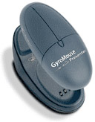
p5: gyromouse.jpg
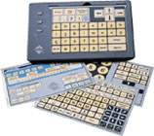
p6 touchpad-1.jpg
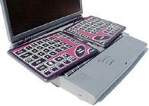
p6 touchpad-2.jpg
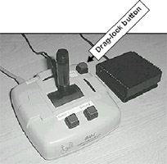
p7 joystick.jpg
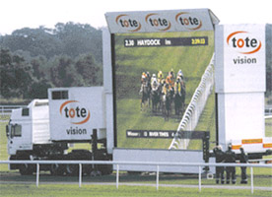
p8 led-display.jpg
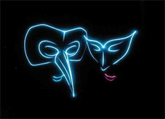
p9 laser-display.jpg
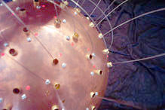
p10 copper-urchin.jpg
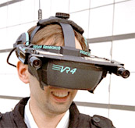
p10 vr-headset.jpg
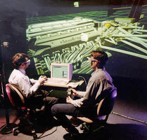
p11 vr-1.jpg
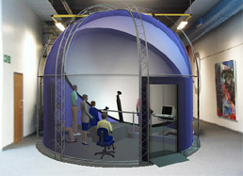
p11 vr-2.jpg
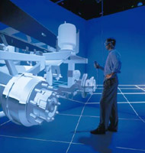
p11 vr-3.jpg
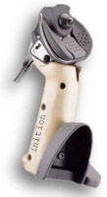
p12 position-track-1.jpg
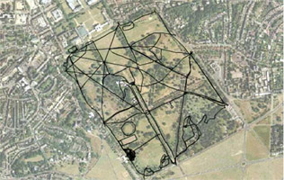
p12 position-track-2.jpg
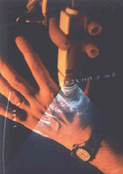
p12 sonic-flashlight.jpg
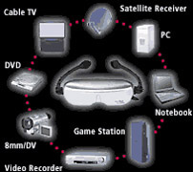
p13 eye-trek.jpg
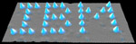
p13 ibm.jpg
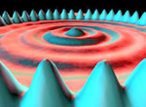
p13 quantum-corral.jpg
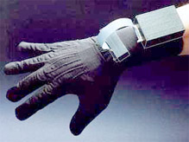
p14 dataglove.jpg
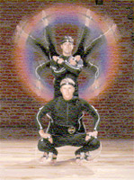
p15 motion-sensor.jpg
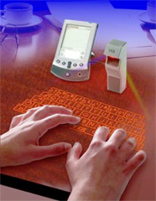
p16 ir-keyboard.jpg
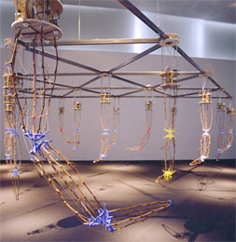
p16 autopoiesis.jpg
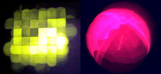
p16 sensorgrid.jpg
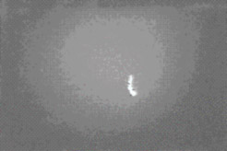
p17 infra-red-video.jpg

p17 steve-mann.jpg
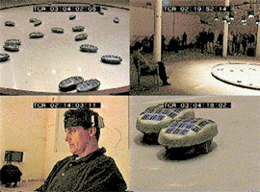
p18 terrain.jpg
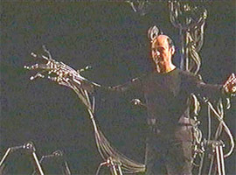
p19 stelarc.jpg
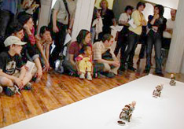
p19 artbot-sumi.jpg
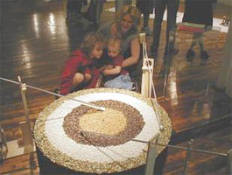
p19 artbot-turntable.jpg
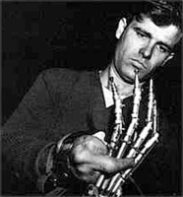
p20 mark_pauline.jpg
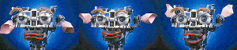
p20 kismet-faces.jpg
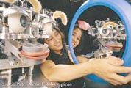
p20 kismet.jpg
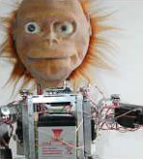
p21 lucy.jpg
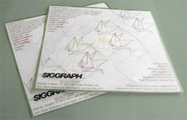
p23 origami-paper.jpg
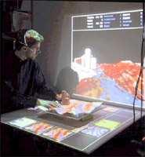
p23 3D-scanner.jpg
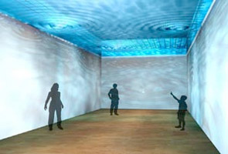
p23 undertoe.jpg
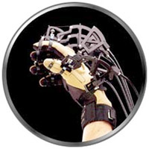
p24 haptic-glove.jpg
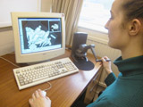
p24 karen-welsh1.jpg
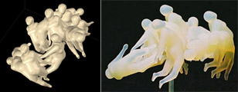
p24 karen-welsh2.jpg
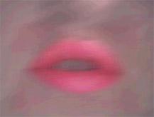
p25 damien-robinson.jpg
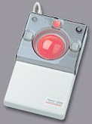
p27 trackball.jpg
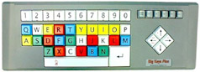
p27 large-keyboard.jpg
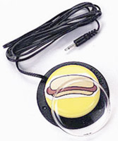
p28 ablenet-switch.jpg
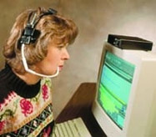
p28 headmouse.jpg
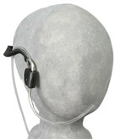
p28 breath-switch.jpg
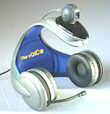
p30 voice-headset.jpg
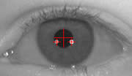
p30 eyegaze.jpg
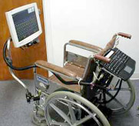
p30 eyegaze-wheelchair.jpg
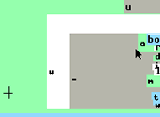
p31 dasher.gif

